Transfer Learning based Detection of Fetal Brain Abnormalities in MRI Scans

Project-1 Synopsis

Submitted in partial fulfillment for the award of the degree
Of
Bachelor in Technology
In
Computer Science & Engineering



Submitted by:
Name & Roll No : Prince Tiwari (2320485)
Name & Roll No : Saloni Nayak (2320494)
Name & Roll No : Tamanna Mal (2320502)

Department of Computer Science & Engineering CGC-College of Engineering
Landran, Mohali Session: 2023-24

CERTIFICATE

Certified that Project work entitled Transfer learning based Detection of Fetal Brain abnormalities in MRI Scans is a bonafide work carried out in the 6th semester by Prince Tiwari(2320485) , Saloni Nayak (2320494) and Tamanna Mal (2320502) for Project-1(BTCS 603-18) as a part of Bachelor of Technology in Computer Science & Engineering at CGC- College of Engineering, Landran from I.K.Gujral Punjab Technical University, Jalandhar.

Date: Signature of Students

This is to certify that the above statement made by the candidate is correct to best of my knowledge.

Date: Signature of Supervisor
Ms. Gagandeep Kaur

ACKNOWLEDGEMENT

We would like to express our sincere gratitude to the Director-Principal, CGC College of Engineering, Landran, for providing this opportunity to carry out the present work.
The constant guidance and encouragement received from Head, Department of Computer Science and Engineering, Landran has been of great help in carrying our present work and helped me in completing this project with success.
We would like to express a deep sense of gratitude to my Project Supervisor Ms. Gagandeep Kaur , CSE department for the guidance and support in defining the problem and towards the completion of our project work. Without his/her wise counsel and able guidance, it would have been impossible to complete the project in this manner.
We are also thankful to all the faculty and staff members of Department of Computer Science and Engineering for their intellectual support throughout the course of this work.

Name & Roll No : Prince Tiwari (2320485)
Name & Roll No : Saloni Nayak (2320494)
Name & Roll No : Tamanna Mal (2320502)

ABSTRACT

Fetal brain abnormalities occur in roughly 3 out of every 1,000 pregnancies, making early detection a vital necessity for effective clinical intervention and helping parents make informed decisions about their future. While ultrasound is the standard screening tool, Magnetic Resonance Imaging (MRI) offers much clearer detail of soft tissues, providing a more comprehensive view of the developing brain between 16 and 39 weeks of gestation. Despite its benefits, the manual review of these complex scans is a slow process that requires specialized expertise and is often subject to different interpretations by different doctors. To bridge this gap, this project introduces an automated system designed to detect and classify fetal brain abnormalities using advanced deep learning techniques.
By utilizing Transfer Learning, the system builds upon established neural network architectures like VGG16, ResNet50, and InceptionV3. These models are fine-tuned using a specialized dataset of fetal MRI images to recognize specific conditions such as Dandy-Walker Malformation, colpocephaly, and cerebellar hypoplasia, among others. The process involves cleaning the images, expanding the dataset through augmentation to improve reliability, and using the pre-trained models to identify subtle patterns that might be missed by the human eye. The success of the system is measured through rigorous statistical metrics to ensure it meets the high standards required for medical diagnostics.
Ultimately, this technology serves as a powerful computer-aided diagnostic tool that supports healthcare providers, especially in areas where expert radiologists are in short supply. By integrating these intelligent frameworks into routine screenings, clinicians can achieve more consistent and accurate results. This project aligns with recent scientific breakthroughs showing that deep learning can outperform traditional methods, offering a faster and more reliable way to monitor fetal health and improve outcomes for families.

List of Contents

Chapter | Description | Pg. No.
 | Certificate | i
 | Acknowledgement | ii
 | Abstract | iii
1 | Introduction | 1-2
2 | Feasibility Study | 3
3 | Literature Survey | 4-5
4 | Methodology | 6-8
5 | Facilities Required | 9
 | References | 10

CHAPTER 1 : Introduction

  - Background

Fetal brain development goes on throughout the whole pregnancy, and its pretty sensitive stuff. Things can go wrong in there, leading to all sorts of congenital issues. Like neural tube defects or ventriculomegaly, those are some of the main ones. Then theres Dandy-Walker malformation, holoprosencephaly, and agenesis of the corpus callosum. These problems show up a lot around the world, and they can be really serious for the baby.

I think the numbers are kind of shocking. The International Society of Ultrasound in Obstetrics and Gynecology says central nervous system malformations happen in about 1 in 100 births. That adds up to maybe 150,000 to 170,000 cases every year just in China. India has similar rates too, which puts a big strain on their prenatal care systems. It seems like healthcare has to deal with a ton from this.

Anyway, MRI has become this key way to check on the fetal brain without any invasion. Its not like ultrasound, where sometimes its hard to see clearly. MRI gives better contrast for soft tissues, and it doesnt get messed up by if the mom is obese or not. You can get views from different planes of the babys head structure, and it works across gestational ages from 16 to 39 weeks. That covers a lot.

But reading fetal MRI right is still something only specialists do well. Theres a lot of difference in how places and doctors diagnose it, which makes outcomes vary. I might be oversimplifying, but it feels like that part gets tricky, not everyone agrees on what they see.

  - Problem Statement

Diagnosing fetal brain problems from MRI scans by hand takes a lot of time. It needs real expertise in radiology too, and different doctors might see things differently sometimes. That variability is a big issue.

There's this worldwide shortage of trained radiologists and sonologists. Especially in rural areas or places in the developing world, it's hard to find them. So, a bunch of these abnormalities just don't get noticed until the baby is born. That means missing chances to do something about it earlier, which seems frustrating.

I think automated systems try to help, but they are pretty limited right now. Most only do basic stuff, like saying normal or abnormal, nothing more detailed. And even then, the accuracy isn't great for all kinds of abnormalities, especially when you consider how gestational ages vary. It feels like they fall short there, not covering everything properly. Some might work okay for certain cases, but overall, it's not sufficient.

  - Proposed Solution

This project is about setting up an automated way to classify fetal MRI brain images using transfer learning. It takes pre-trained deep convolutional neural networks, or CNNs, and fine-tunes them on these specific images to spot differences.

The main goal is to sort MRI scans into normal ones and a bunch of abnormal categories. It should do this pretty accurately, I think, so doctors can use it as a computer-aided diagnostic tool in clinics or for screening. That part seems useful, but getting the fine-tuning right might be tricky with all the variations in fetal images.

Some abnormal cases could overlap or something, which makes the multiple categories a bit messy to handle. Anyway, the framework relies on those CNNs to provide reliable results overall.

  - Objectives

- To implement a transfer learning pipeline using pre-trained CNN models (VGG16, ResNet50, InceptionV3) for fetal brain MRI classification.
- To apply effective preprocessing and data augmentation techniques to address data imbalance and improve model generalization.
- To classify fetal brain MRI scans into normal and multiple abnormal categories across diverse gestational ages.
- To evaluate model performance using accuracy, precision, recall, F1-score, and AUC-ROC metrics.
- To develop a system that can assist clinicians in early prenatal detection of fetal brain disorders.
  - Scope
The project uses the publicly available Kaggle Fetal MRI Brain Images Dataset, encompassing MRI scans of fetuses between 16 and 39 weeks of gestational age. The system is designed for research and clinical-assistance purposes, with potential deployment as a web-based or hospital-integrated CAD tool. Future scope includes integration with 3D volumetric MRI data and expansion to additional abnormality categories.

CHAPTER 2 : Feasibility Study

2.1 Technical Feasibility

The project is technically feasible given the availability of:
- The Kaggle Fetal MRI Brain Images Dataset, a publicly accessible labeled dataset of fetal brain MRI scans.
- Established deep learning frameworks — TensorFlow/Keras and PyTorch — which support implementation of transfer learning pipelines.
- Pre-trained CNN models (VGG16, ResNet50, InceptionV3) trained on ImageNet, readily available for fine-tuning.
- GPU-enabled computing environments (Google Colab, Kaggle Kernels) that provide sufficient computational resources for model training.
- Python libraries (NumPy, OpenCV, scikit-learn, Matplotlib) for preprocessing, evaluation, and visualization.
2.2 Operational Feasibility
Because the suggested system is made to work with current clinical workflows, it is operationally feasible. A user-friendly interface allows radiologists and clinicians to upload MRI scans, obtain automated classification outputs with confidence scores, and use the results as a secondary opinion tool. The system ensures compatibility with standard medical practice by augmenting rather than replacing clinical judgment.

2.3 Economic Feasibility
The project utilizes open-source tools, free cloud computing environments, and a publicly available dataset — making the overall development cost minimal. The long-term economic benefit is substantial: early prenatal detection of brain abnormalities reduces costs associated with post-natal interventions, hospitalization, and special care. The system can be deployed in resource-limited settings where specialist access is unavailable, broadening its economic impact.

2.4 Schedule Feasibility
With benchmarks for dataset preparation and preprocessing, model selection and training, evaluation, and documentation, the project is scheduled to take place over a semester (roughly five to six months). The schedule is feasible because training CNNs from scratch takes a lot more time than using pre-trained models via transfer learning.

CHAPTER 3 : Literature Survey
Deep learning-based medical image classification, fetal brain MRI analysis, transfer learning in brain imaging, and machine learning methods for fetal abnormality detection have all been thoroughly reviewed. Below is a summary of the major research papers that were examined:

S.No. | Authors | Title / Focus | Methodology | Key Results
1 | Xie et al. (2020) – UOG | DL classification of fetal brain ultrasound as normal/abnormal | CNN-based segmentation + binary classification on 29,419 fetal ultrasound images; heat maps for lesion localization | Overall accuracy: 96.3%; Sensitivity: 96.9%; Specificity: 95.9%; AUC: 0.989
2 | Attallah, Sharkas & Gadelkarim (2019) – Brain Sciences | Fetal brain abnormality classification from MRI images across gestational ages | DWT, Gabor filters, GLCM feature extraction + KNN, Random Forest, RBF network, Naïve Bayes classifiers; ensemble models | Best accuracy: 95.6% (KNN); AUC: 99%; Ensemble models improved individual classifier results
3 | Valverde et al. (2021) – J. Imaging | Systematic review of Transfer Learning in MR Brain Imaging | Review of 129 studies; CNN-based pretraining & fine-tuning; categorized instance-based, feature-based, and parameter-based TL | CNNs used in 68.22% of studies; parameter-based TL (fine-tuning) most prevalent; pretrained ImageNet CNNs widely adopted
4 | Baumgartner et al. (2017) | SonoNet: Real-time detection & localization of fetal standard planes (ultrasound) | CNN-based detection of 13 standard fetal scan planes in freehand ultrasound | State-of-the-art plane detection; baseline for fetal brain localization research
5 | Ball et al. (2016) | ML for neonatal functional connectivity in preterm brain | ICA + SVM classification on preterm brain MRI | 80% classification accuracy — surpassed by proposed and related fetal-specific methods

3.1 Research Gaps Identified

- Most previous research on brain MRI classification focuses on adult or neonatal brain scans, while fetal brain scans have received limited attention.
- There is a shortage of studies specifically targeting fetal brain MRI analysis.
- Many existing studies only perform binary classification (normal vs abnormal), but clinical applications require multi-class classification to identify different types of abnormalities.
- Transfer learning techniques have shown strong performance in other brain imaging fields, but very little research has applied transfer learning to fetal MRI analysis.
- Existing fetal MRI studies generally use small datasets ranging from 83 to 227 images, which limits the robustness of the models.
- Large-scale dataset experiments for fetal MRI classification are still limited.
- Current systems do not provide a unified framework capable of handling both:
- Multi-class abnormality classification
- Fetal MRI images covering a wide gestational age range (16–39 weeks).

CHAPTER 4 : Methodology
4.1 Dataset
The project uses the Kaggle Fetal MRI Brain Images Dataset. This dataset contains T2-weighted MRI scans of fetal brains at gestational ages ranging from 16 to 39 weeks, organized into the following categories:
- Normal
- Dandy-Walker Malformation (DWM)
- Agenesis of the Corpus Callosum (ACC)
- Colpocephaly
- Cerebellar Hypoplasia
- Polymicrogyria
- Mega-Cisterna Magna
- Agenesis of the Septi Pellucidi
The dataset contains MRI scans in coronal, sagittal, and axial planes. Class imbalance is addressed using data augmentation techniques.
4.2 Preprocessing
- Image resizing to 224×224 pixels to match the input requirements of pre-trained CNN models.
- Normalization: pixel values scaled to [0, 1] range.
- Data augmentation: random horizontal flipping, rotation (±30°), zoom, brightness adjustment, and width/height shifts to increase dataset diversity and reduce overfitting.
- Train-validation-test split: 70% training, 15% validation, 15% test (split at subject level to avoid data leakage).
4.3 Transfer learning pipeline
The following pre-trained CNN architectures are fine-tuned on the fetal MRI dataset:
• VGG16 Deep architecture with 16 weight layers the final fully connected layers are replaced with custom classification heads
• ResNet50 uses residual connections to solve vanishing gradient issues while achieving high accuracy in medical imaging tasks
• InceptionV3 uses inception modules to extract features at multiple scales which have been shown to work for brain imaging studies
The fine-tuning process begins with the freezing of all convolutional base layers. The training process begins with the custom classification head which consists of Global Average Pooling followed by Dense and Dropout and Softmax layers. The last few convolutional blocks are unfrozen for end-to-end fine-tuning with a low learning rate.
4.4 Evaluation Metrics
- Classification Accuracy
- Precision, Recall (Sensitivity), F1-Score
- Area Under the ROC Curve (AUC-ROC)
- Confusion Matrix (per-class performance)
4.5 System Architecture
[Figure: Fetal MRI Input → Preprocessing → Pre-trained CNN (VGG16/ResNet50/InceptionV3) → Fine-tuning → Classification Head → Output: Normal / Abnormality Type]

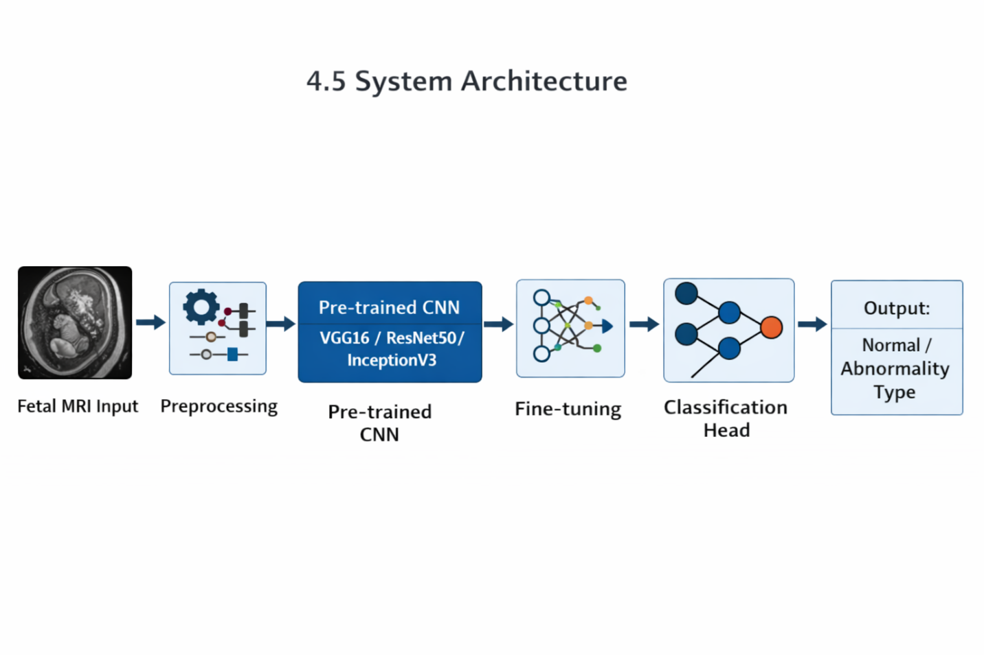
Fig 4.1
4.6 Tools and Technologies
- Programming Language: Python 3.x
- Deep Learning Framework: TensorFlow 2.x / Keras
- Pre-trained Models: VGG16, ResNet50, InceptionV3 (ImageNet weights)
- Image Processing: OpenCV, PIL
- Data Analysis & Visualization: NumPy, Pandas, Matplotlib, Seaborn
- Evaluation: scikit-learn
- Development Environment: Google Colab / Kaggle Notebook (GPU)

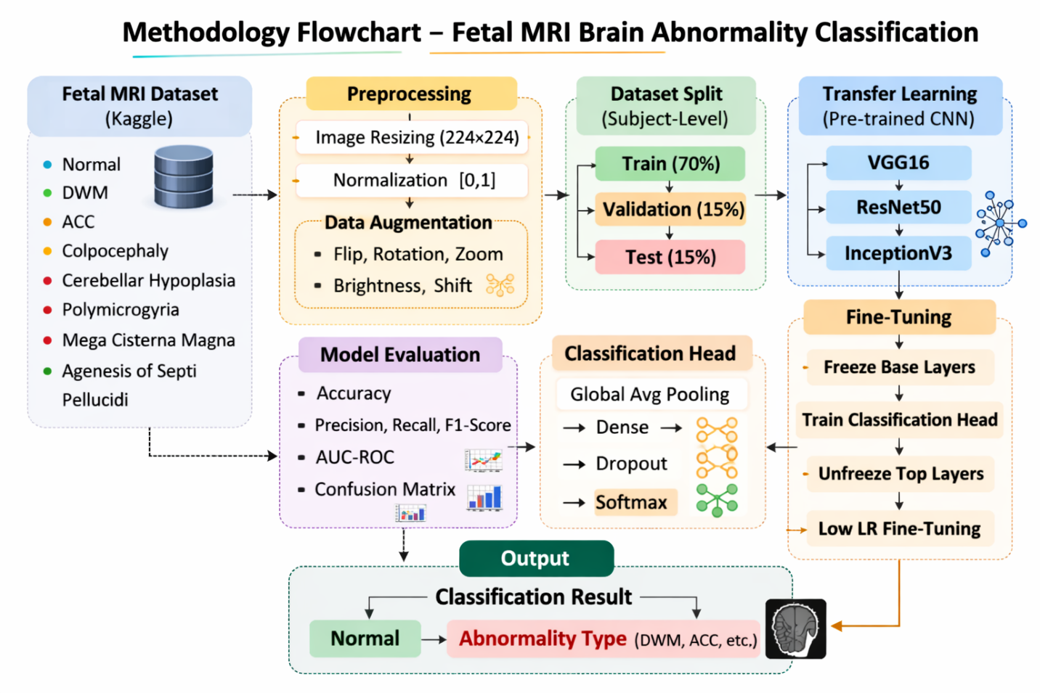
Fig 4.2

CHAPTER 5 : Facilities Required
5.1 Hardware Requirements

Component | Specification
Processor | Intel Core i5 or higher / AMD Ryzen 5 or higher
RAM | Minimum 8 GB (16 GB recommended)
GPU (for training) | NVIDIA GPU (Colab T4/A100) or equivalent (cloud)
Storage | Minimum 50 GB free space
Internet Connection | Required for dataset download, cloud training, and library installation

5.2 Software Requirements

Software / Library | Purpose
Python 3.x | Core programming language
TensorFlow 2.x / Keras | Deep learning model development & training
OpenCV / PIL | Image preprocessing and augmentation
scikit-learn | Evaluation metrics, confusion matrix
Matplotlib / Seaborn | Data visualization and result plotting
Google Colab / Kaggle Notebook | Cloud-based GPU training environment

References
1. U-Net: Convolutional Networks for Biomedical Image Segmentation
https://link.springer.com/content/pdf/10.1007/978-3-319-24574-4_28.pdf
2. Attention-guided deep learning for gestational age prediction using fetal brain MRI
https://www.nature.com/articles/s41598-022-05468-5.pdf
3. Fetal Brain Abnormality Classification from MRI Images of Different Gestational Age
https://www.mdpi.com/2076-3425/9/9/231/pdf?version=1568942575
4. Transfer Learning in Magnetic Resonance Brain Imaging: A Systematic Review
https://www.mdpi.com/2313-433X/7/4/66/pdf?version=1617939369
5. FETAL MRI BRAIN IMAGES DATASET from Kaggle
6. Towards a Better Understanding of Transfer Learning for Medical Imaging: A Case Study
https://www.mdpi.com/2076-3417/10/13/4523/pdf?version=1594172386
7. COMPARATIVE ANALYSIS OF PERFORMANCE OF DEEP CNN BASED FRAMEWORK FOR BRAIN MRI CLASSIFICATION USING TRANSFER LEARNING
https://jestec.taylors.edu.my/Vol%2016%20Issue%204%20August%202021/16_4_9.pdf

